E-Commerce Customer Behaviour Analysis

import pandas as pd
import plotly.express as px
import plotly.graph_objects as go
import plotly.io as pio
import plotly.colors as colors
pio.templates.default = "plotly_white"

data = pd.read_csv("Sample - Superstore.csv", encoding='latin-1')
data.head()
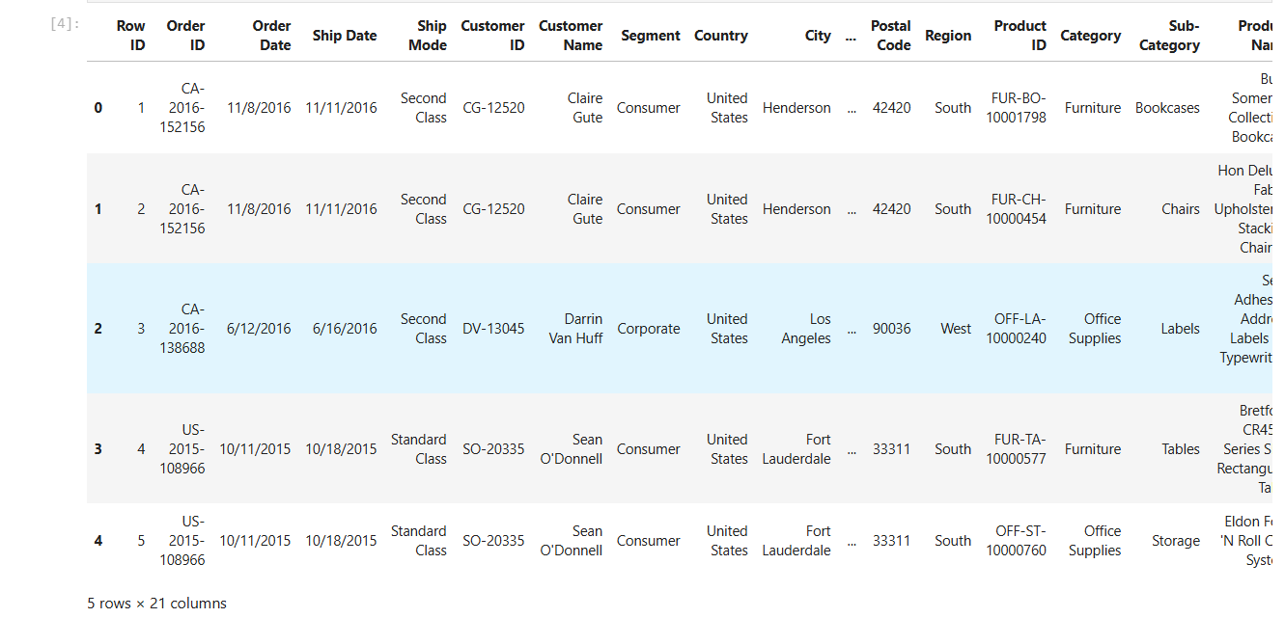

Descriptive statistics of the dataset
data.describe()

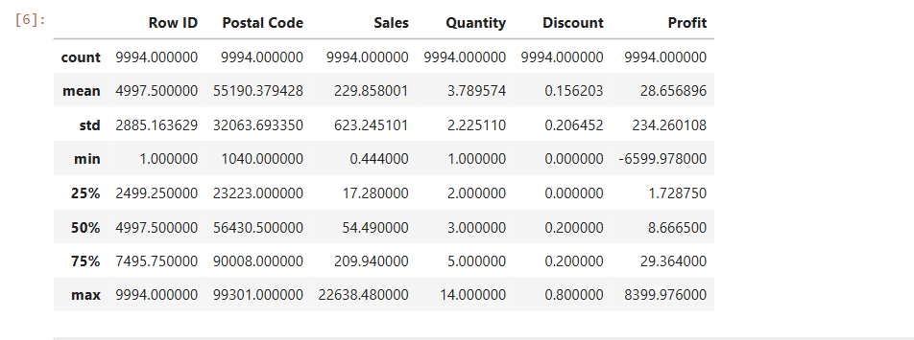

data.info()
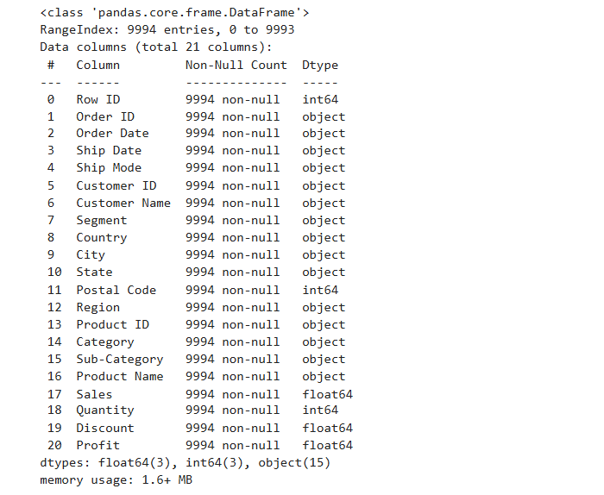
data.head()


Converting Date Columns
data['Order Date'] = pd.to_datetime(data['Order Date'])
data['Ship Date'] = pd.to_datetime(data['Ship Date'])

Adding New Date-Based Columns
data['Order Month'] = data['Order Date'].dt.month
data['Order Year'] = data['Order Date'].dt.year
data['Order Day of Week'] = data['Order Date'].dt.dayofweek

data.head()
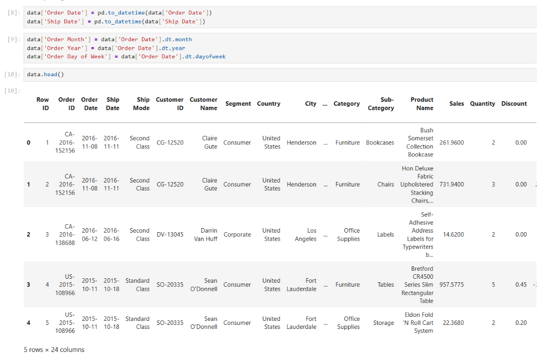

Monthly Sales Analysis
sales_by_month = data.groupby('Order Month')['Sales'].sum().reset_index()
fig = px.line(sales_by_month,
x='Order Month',
y='Sales',
title='Monthly Sales Analysis')
fig.show()
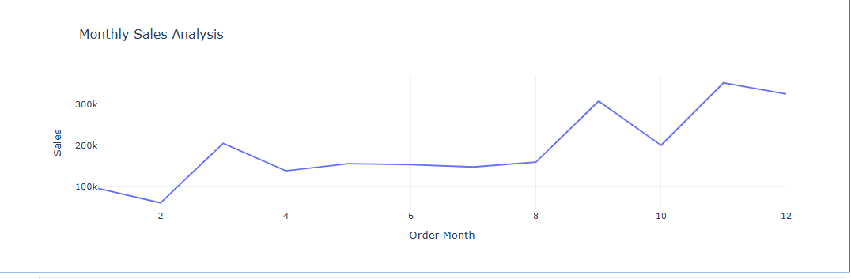
Sales Analysis by Category
sales_by_category = data.groupby('Category')['Sales'].sum().reset_index()

fig = px.pie(sales_by_category,
values='Sales',
names='Category',
hole=0.5,
color_discrete_sequence=px.colors.qualitative.Pastel)

fig.update_traces(textposition='inside', textinfo='percent+label')
fig.update_layout(title_text='Sales Analysis by Category', title_font=dict(size=24))

fig.show()

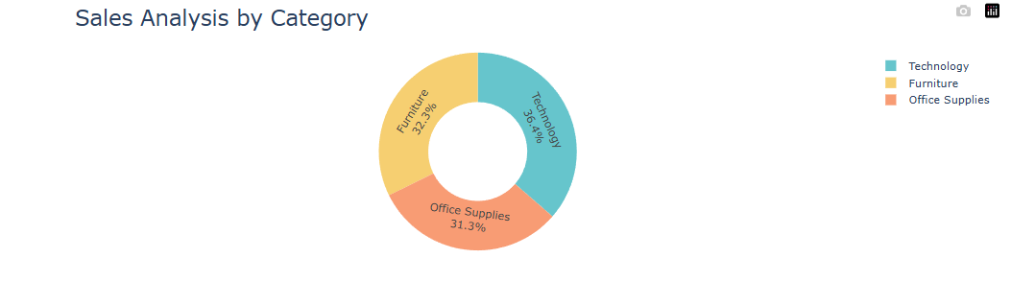
Sales Analysis by Sub-Category
sales_by_subcategory = data.groupby('Sub-Category')['Sales'].sum().reset_index()
fig = px.bar(sales_by_subcategory,
x='Sub-Category',
y='Sales',
title='Sales Analysis by Sub-Category')
fig.show()
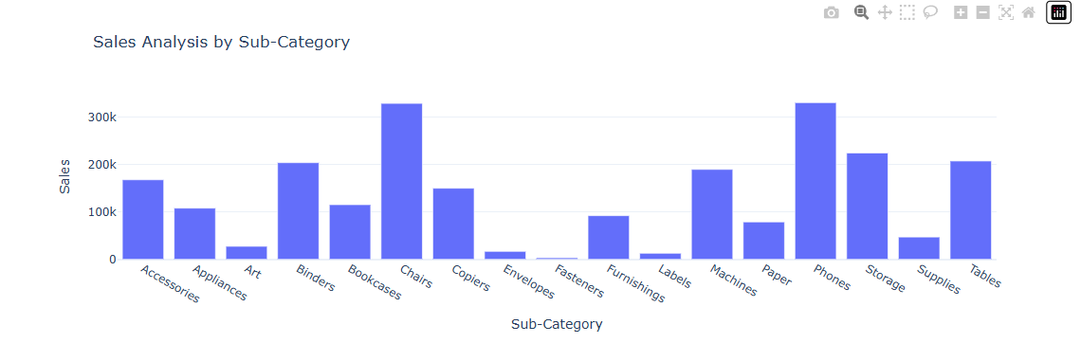
Monthly Profit Analysis
profit_by_month = data.groupby('Order Month')['Profit'].sum().reset_index()
fig = px.line(profit_by_month,
x='Order Month',
y='Profit',
title='Monthly Profit Analysis')
fig.show()

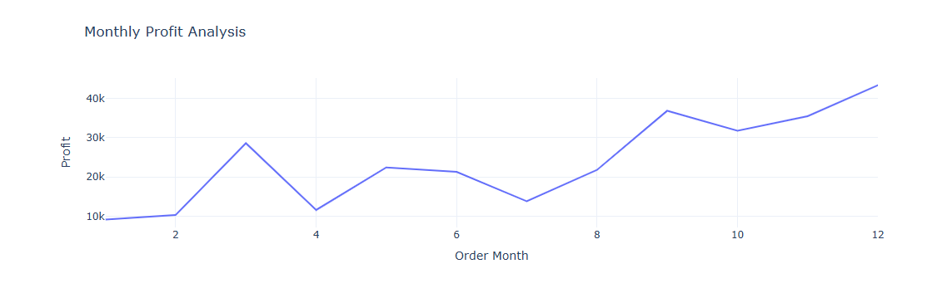
Profit Analysis by Category
profit_by_category = data.groupby('Category')['Profit'].sum().reset_index()

fig = px.pie(profit_by_category,
values='Profit',
names='Category',
hole=0.5,
color_discrete_sequence=px.colors.qualitative.Pastel)

fig.update_traces(textposition='inside', textinfo='percent+label')
fig.update_layout(title_text='Profit Analysis by Category', title_font=dict(size=24))

fig.show()
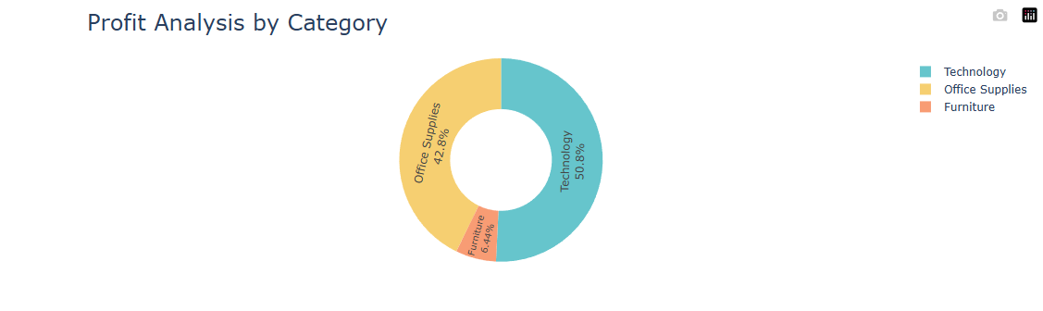
Profit Analysis by Sub-Category
profit_by_subcategory = data.groupby('Sub-Category')['Profit'].sum().reset_index()
fig = px.bar(profit_by_subcategory, x='Sub-Category',
y='Profit',
title='Profit Analysis by Sub-Category')
fig.show()
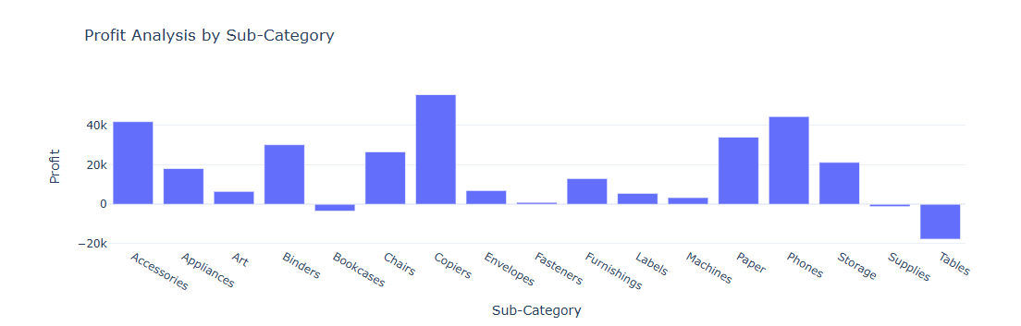

Sales and Profit Analysis by Customer Segment
sales_profit_by_segment = data.groupby('Segment').agg({'Sales': 'sum', 'Profit': 'sum'}).reset_index()

color_palette = colors.qualitative.Pastel

fig = go.Figure()
fig.add_trace(go.Bar(x=sales_profit_by_segment['Segment'],
y=sales_profit_by_segment['Sales'],
name='Sales',
marker_color=color_palette[0]))

fig.add_trace(go.Bar(x=sales_profit_by_segment['Segment'],
y=sales_profit_by_segment['Profit'],
name='Profit',
marker_color=color_palette[1]))

fig.update_layout(title='Sales and Profit Analysis by Customer Segment',
xaxis_title='Customer Segment', yaxis_title='Amount')

fig.show()
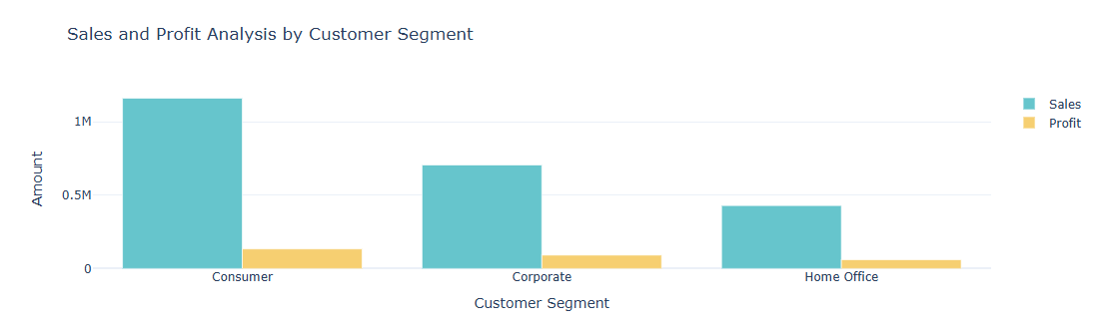

Analyse sales-to-profit ratio
sales_profit_by_segment = data.groupby('Segment').agg({'Sales': 'sum', 'Profit': 'sum'}).reset_index()
sales_profit_by_segment['Sales_to_Profit_Ratio'] = sales_profit_by_segment['Sales'] / sales_profit_by_segment['Profit']
print(sales_profit_by_segment[['Segment', 'Sales_to_Profit_Ratio']])



